***NODEJs***

* **Introduction to NPM**

1. What is npm?

* npm is the package manager for JavaScript.

1. Package Manager

* Problem 🡺 Code
* Same problem 🡺 Reuse the Code

1. Modules and Package

* Individual files containing reusable code are called modules.
* Package is a directory with one or more modules and along with a special file called package.JSON
* package.JSON contains metadata about the package.

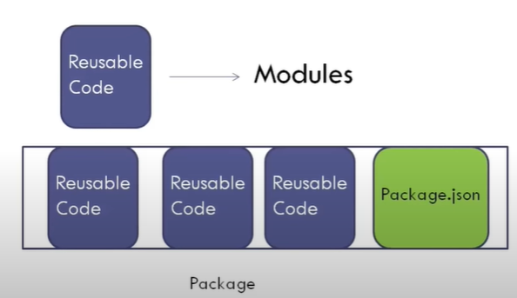

* **Getting Started with NPM**

1. **NPM** is shipped with node.js so in order to have NPM on our machines we need to download and install node.js.
2. **node - v** gives the version of node installed on our system which in my system is **v16.13.1.**
3. Now that we have node installed, we can run **npm -v** and this gives the version of **npm** on our machines which in my system is **8.1.2.**

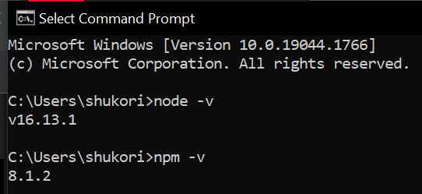

* **NPM Help**

1. **npm -help** shows us the typical usage of **npm**, i.e., it is **npm** followed by a command name

**npm <command>**

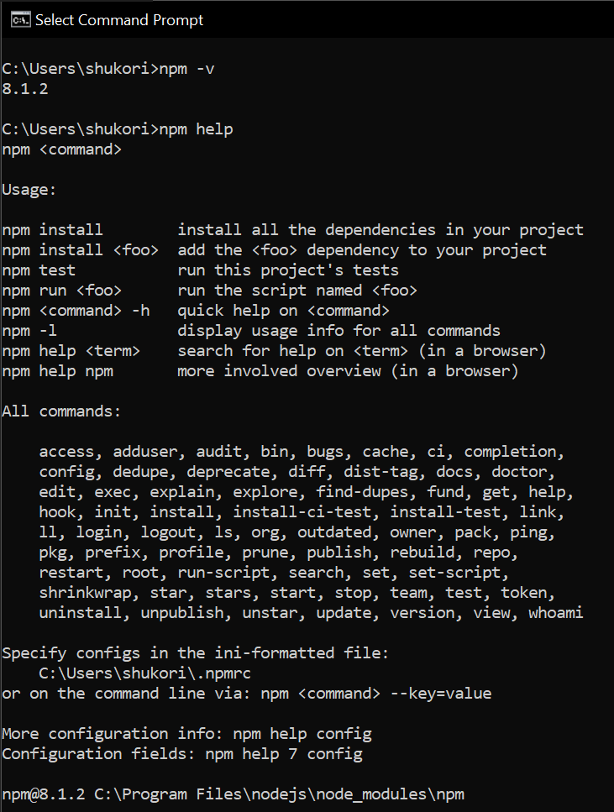

1. **npm install -h** gives us the different ways we can use **npm** **install**.

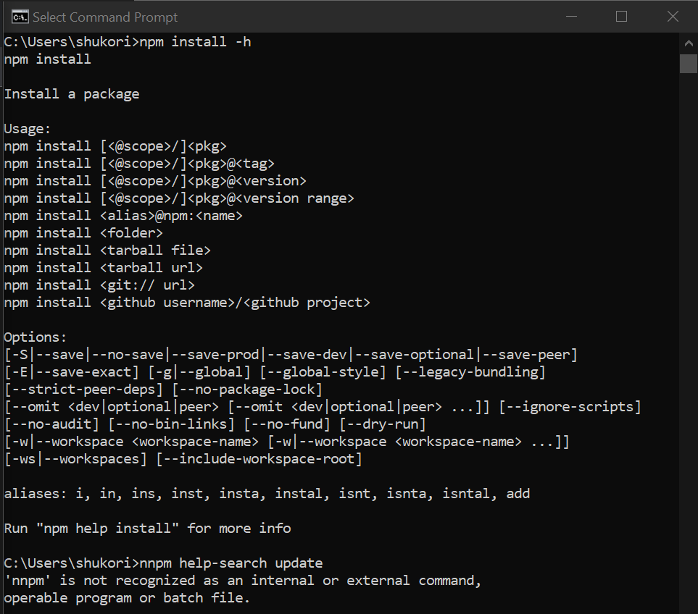

1. **npm help-search <text>:** it allow us to specify some text and it is going to search the **npm** documentation for that text.

Here is an example of npm **help-search update,** when we run this command, it gives us the **top hits** for the text update and their corresponding documentation in the browser.

